

**WEB COURSE**

ClassParticipation



Name : M. Ahmed

Roll No: 21F-9295

Section : 6-E

Task : 1

<!DOCTYPE html>

<html lang="en">

  <head>

    <meta charset="utf-8" />

    <meta name="viewport" content="width=device-width, initial-scale=1" />

    <title>Web Programming </title>

    <link rel="stylesheet" href="t1.css" />

    <link

      href="https://cdn.jsdelivr.net/npm/bootstrap@5.3.2/dist/css/bootstrap.min.css"

      rel="stylesheet"

      integrity="sha384-T3c6CoIi6uLrA9TneNEoa7RxnatzjcDSCmG1MXxSR1GAsXEV/Dwwykc2MPK8M2HN"

      crossorigin="anonymous"

    />

  </head>

  <style>

  a {

      text-decoration: none;

    }

    .box {

      position: relative;

      padding-right: 30px;

    }

    .close-btn {

      position: absolute;

      top: 50%;

      transform: translateY(-50%);

      right: 0;

      padding: 5px;

      cursor: pointer;

    }

  </style>

  <body>

    <div class="container-fluid">

        <a href="https://www.w3schools.com/bootstrap/bootstrap_ver.asp ">

          <div class="link_decoration bg-success text-success bg-opacity-50 s box">

        Feel good about bootstrap

        <span class="close-btn" onclick="hideBox(this)">×</span>

      </div>

    </a>

    <a href="https://www.w3schools.com/bootstrap/bootstrap_ver.asp ">

      <div class="link_decoration text-success bg-primary bg-opacity-25 s box">

        Feel Informed about bootstrap

        <span class="close-btn" onclick="hideBox(this)">×</span>

      </div>

    </a>

      <a href="https://www.w3schools.com/bootstrap/bootstrap_ver.asp ">

      <div class="link_decoration text-warning bg-warning bg-opacity-25 s box">

        Feel warned about Bootstrap

        <span class="close-btn" onclick="hideBox(this)">×</span>

      </div>

    </a>

      <a href="https://www.w3schools.com/bootstrap/bootstrap_ver.asp ">

      <div class="link_decoration text-warning bg-warning bg-opacity-25 s box">

        Maybe I should read the docs...

        <span class="close-btn" onclick="hideBox(this)">×</span>

      </div>

    </a>

      <a href="https://www.w3schools.com/bootstrap/bootstrap_ver.asp ">

      <div class="link_decoration bg-danger text-danger bg-opacity-25 s box">

        Danger zone

        <span class="close-btn" onclick="hideBox(this)">×</span>

      </div>

    </a>

      <a href="https://www.w3schools.com/bootstrap/bootstrap_ver.asp ">

      <div class="link_decoration bg-danger text-danger bg-opacity-25 s box">

        I really should read the docs...

        <span class="close-btn" onclick="hideBox(this)">×</span>

      </div>

    </a>

    </div>

    <script

      src="https://cdn.jsdelivr.net/npm/bootstrap@5.3.2/dist/js/bootstrap.bundle.min.js"

      integrity="sha384-C6RzsynM9kWDrMNeT87bh95OGNyZPhcTNXj1NW7RuBCsyN/o0jlpcV8Qyq46cDfL"

      crossorigin="anonymous"

    ></script>

    <script>

      function hideBox(element) {

        var box = element.closest('.box');

        box.style.display = 'none';

      }

    </script>

  </body>

</html>

Output :

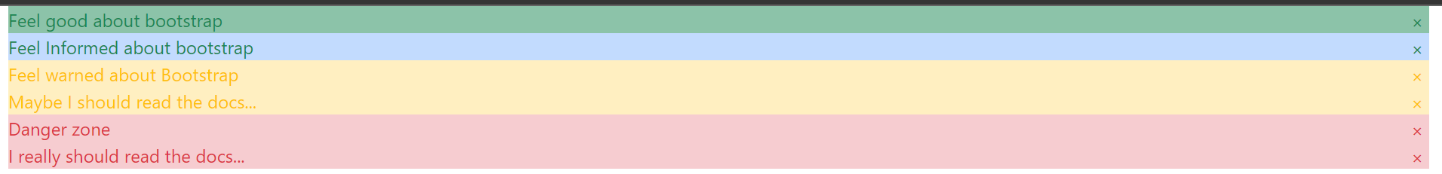

Task 2 :

<!DOCTYPE html>

<html lang="en">

  <head>

    <meta charset="utf-8" />

    <meta name="viewport" content="width=device-width, initial-scale=1" />

    <title>Web Programing</title>

    <link rel="stylesheet" href="t1.css" />

    <link

      href="https://cdn.jsdelivr.net/npm/bootstrap@5.3.2/dist/css/bootstrap.min.css"

      rel="stylesheet"

      integrity="sha384-T3c6CoIi6uLrA9TneNEoa7RxnatzjcDSCmG1MXxSR1GAsXEV/Dwwykc2MPK8M2HN"

      crossorigin="anonymous"

    />

  </head>

  <style>

    body{

        padding-top: 2%;

        padding-left: 5%;

    }

  </style>

  <body>

    <div class="container-fluid">

      <button type="button" class="btn">Basic</button>

      <button type="button" class="btn btn-primary">Primary</button>

      <button type="button" class="btn btn-secondary">Secondary</button>

      <button type="button" class="btn btn-success">Success</button>

      <button type="button" class="btn btn-info">Info</button>

      <button type="button" class="btn btn-warning">Warning</button>

      <button type="button" class="btn btn-danger">Danger</button>

      <button type="button" class="btn btn-dark">Dark</button>

      <button type="button" class="btn btn-light">Light</button>

      <button type="button" class="btn btn-link">Link</button>

    </div>

    <script

      src="https://cdn.jsdelivr.net/npm/bootstrap@5.3.2/dist/js/bootstrap.bundle.min.js"

      integrity="sha384-C6RzsynM9kWDrMNeT87bh95OGNyZPhcTNXj1NW7RuBCsyN/o0jlpcV8Qyq46cDfL"

      crossorigin="anonymous"

    ></script>

    <script>

        let buttons = document.getElementsByClassName("btn");

        for (let i = 0; i < buttons.length; i++) {

          buttons[i].addEventListener("click", function () {

            alert("My name is Muhammad Ahmed");

          });

        }

      </script>

  </body>

</html>

Output :

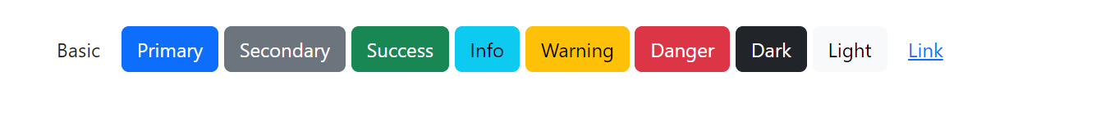

Task 3:

<!DOCTYPE html>

<html lang="en">

  <head>

    <meta charset="utf-8" />

    <meta name="viewport" content="width=device-width, initial-scale=1" />

    <title>Web Programming</title>

    <link

      href="https://cdn.jsdelivr.net/npm/bootstrap@5.3.2/dist/css/bootstrap.min.css"

      rel="stylesheet"

      integrity="sha384-T3c6CoIi6uLrA9TneNEoa7RxnatzjcDSCmG1MXxSR1GAsXEV/Dwwykc2MPK8M2HN"

      crossorigin="anonymous"

    />

    <style>

      body {

        padding-top: 2%;

        padding-left: 10%;

        box-sizing: none;

        font-family: 'Arial', sans-serif;

        background-color: #f8f9fa;

      }

      div {

        display: flex;

        flex-wrap: wrap;

        gap: 10px;

      }

      .in {

        border-radius: 5px;

        border: 2px solid #343a40;

        padding: 5px;

        width: 200px;

        box-sizing: border-box;

        margin: 5px;

      }

      .b1 {

        border: none;

        color: white;

        padding: 10px 20px;

        text-align: center;

        text-decoration: none;

        display: inline-block;

        font-size: 16px;

        margin: 4px 2px;

        cursor: pointer;

        border-radius: 5px;

        background-color: #007bff;

      }

      #res {

        border-radius: 5px;

        border: 2px solid #343a40;

        padding: 5px;

        width: 150px;

        box-sizing: border-box;

        margin: 5px;

        font-weight: bold;

      }

    </style>

  </head>

  <body>

    <div>

      <input class="in" id="v1" placeholder="Enter the 1st number" />

      <input class="in" id="v2" placeholder="Enter the 2nd number" />

    </div>

    <br />

    <button class="b1" id="v3" onclick="Addition()">Add</button>

    <button class="b1" id="v4" onclick="subtract()">Sub</button>

    <button class="b1" id="v5" onclick="multiply()">Mul</button>

    <button class="b1" id="v6" onclick="Divide()">Div</button>

<br></br>

<input class="in" id="res" placeholder="Result" />

    <script>

        let buttons = document.getElementById("v3");

let Addition = () => {

  let i1 = Number(document.getElementById("v1").value);

  let i2 = Number(document.getElementById("v2").value);

  console.log(i1 + i2);

  document.getElementById("res").value = i1 + i2;

};

let subtract = () => {

  let i1 = Number(document.getElementById("v1").value);

  let i2 = Number(document.getElementById("v2").value);

  console.log(i1 - i2);

  document.getElementById("res").value = i1 - i2;

};

let multiply = () => {

  let i1 = Number(document.getElementById("v1").value);

  let i2 = Number(document.getElementById("v2").value);

  console.log(i1 * i2);

  document.getElementById("res").value = i1 * i2;

};

let Divide = () => {

  let i1 = Number(document.getElementById("v1").value);

  let i2 = Number(document.getElementById("v2").value);

  console.log(i1 / i2);

  document.getElementById("res").value = i1 / i2;

};

    </script>

  </body>

</html>

Output :

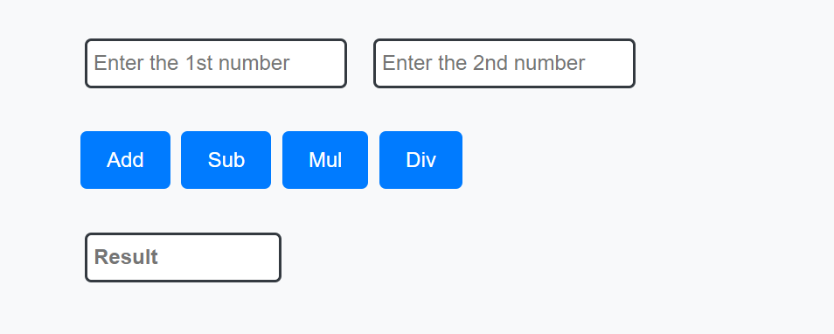

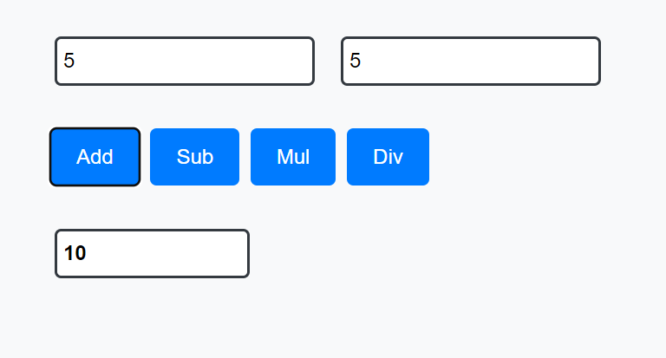

Task 4:

<!DOCTYPE html>

<html lang="en">

  <head>

    <meta charset="utf-8" />

    <meta name="viewport" content="width=device-width, initial-scale=1" />

    <title>Web Programming</title>

    <link

      href="https://cdn.jsdelivr.net/npm/bootstrap@5.3.2/dist/css/bootstrap.min.css"

      rel="stylesheet"

      integrity="sha384-T3c6CoIi6uLrA9TneNEoa7RxnatzjcDSCmG1MXxSR1GAsXEV/Dwwykc2MPK8M2HN"

      crossorigin="anonymous"

    />

    <style>

      body {

        padding: 2% 10%;

        box-sizing: none;

        font-family: 'Arial', sans-serif;

        background-color: #f8f9fa;

      }

      input {

        border-radius: 5px;

        border: 2px solid #343a40;

        padding: 8px;

        width: 250px;

        box-sizing: border-box;

        margin-bottom: 20px;

      }

      #days {

        font-size: 24px;

        margin-bottom: 20px;

      }

      .b1 {

        border: none;

        color: white;

        padding: 10px 20px;

        text-align: center;

        text-decoration: none;

        display: inline-block;

        font-size: 16px;

        margin: 4px 2px;

        cursor: pointer;

        border-radius: 5px;

        background-color: #007bff;

      }

    </style>

  </head>

  <body>

    <input id="v1" type="text" placeholder="Please Enter month name" />

    <h1 id="days"></h1>

    <button class="b1" id="v6" onclick="Display()">Submit</button>

    <script>

      let Display = () => {

        let day = 0;

        let i1 = document.getElementById("v1").value.toLowerCase();

        switch (i1) {

          case "jan":

          case "mar":

          case "may":

          case "jul":

          case "aug":

          case "oct":

          case "dec":

            day = 31;

            break;

          case "apr":

          case "jun":

          case "sep":

          case "nov":

            day = 30;

            break;

          case "feb":

            day = 28;

            break;

          default:

            day = "Invalid input";

            break;

        }

        document.getElementById("days").innerHTML = `${day}`;

      };

    </script>

  </body>

</html>

Output :

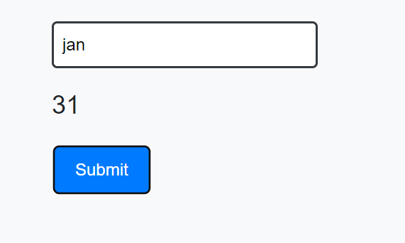

Task 5:

<!DOCTYPE html>

<html lang="en">

  <head>

    <meta charset="utf-8" />

    <meta name="viewport" content="width=device-width, initial-scale=1" />

    <title>Web Programming</title>

    <link

      href="https://cdn.jsdelivr.net/npm/bootstrap@5.3.2/dist/css/bootstrap.min.css"

      rel="stylesheet"

      integrity="sha384-T3c6CoIi6uLrA9TneNEoa7RxnatzjcDSCmG1MXxSR1GAsXEV/Dwwykc2MPK8M2HN"

      crossorigin="anonymous"

    />

    <style>

      body {

        padding: 2% 10%;

        box-sizing: none;

        font-family: 'Arial', sans-serif;

        background-color: #f8f9fa;

      }

      input {

        border-radius: 5px;

        border: 2px solid #343a40;

        padding: 8px;

        width: 250px;

        box-sizing: border-box;

        margin-bottom: 20px;

      }

      #Num {

        margin-top: 20px;

      }

      .b1 {

        border: none;

        color: white;

        padding: 10px 20px;

        text-align: center;

        text-decoration: none;

        display: inline-block;

        font-size: 16px;

        margin: 4px 2px;

        cursor: pointer;

        border-radius: 5px;

        background-color: #007bff;

      }

      h4 {

        color: rgb(77, 118, 175);

      }

    </style>

  </head>

  <body>

    <input id="v1" type="Number" placeholder="Enter Number for Table" />

    <h1 id="Num"></h1>

    <button class="b1" id="v6" onclick="Table()">Submit</button>

    <script>

      let Table = () => {

        let i1 = Number(document.getElementById("v1").value);

        let r = document.createElement("div");

        r.classList.add("Num");

        for (let i = 1; i <= 10; i++) {

          let v1 = document.createElement("h4");

          let v3 = i1 * i;

          v1.innerHTML = `${i1} * ${i} = ${v3}`;

          r.appendChild(v1);

        }

        document.getElementById("Num").appendChild(r);

      };

    </script>

  </body>

</html>

Output :

